**Overview of ELK:**

* Elastic search is a very versatile search engine which is capable of processing unstructured data like logs and structured data like geospatial coordinates.

In order to process large amounts of data and to find key relevant insights within seconds.

1. **Hadoop**: Open source Java based framework that supports the processing and storage of extremely large data sets in distributed computing environment.
2. **NoSQL** Databases like mongoDB, couch DB and Kassandra can scale horizontally and make use of clustered compute and storage capacities of hundreds or thousands of machines joined together.
3. All these data that are flowing across network needs several data processing jobs, ETL tools are designed to help with data integration, data quality and data management
4. **The end goal is to perform the Business Analytics.**
5. Business analytic tools - Jasper soft
6. **ELK – Set of tools (technologies) which are instrumental in processing large amounts of data.**

**ELK stack: (Separate projects by Vendor Elastic)**

**Elastic Search:** Search server based on Apache Lucine, helps to store index and search data.

**Log Stash:** log management tool used for centralized logging, enrichment and parsing.

**Kibana:** Browser based HTML5 dashboard used to visualize elastic search data.

This Open Source ELK stack provides the ability to perform operational and data analytics including deep search functionality on almost any type of structured or unstructured data source.

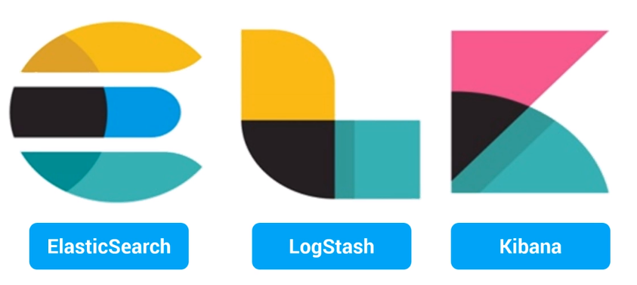

Data constantly flows into our systems and quickly grow to be fat. As data grows faster your analytics will slow down resulting in sluggish insights and becomes a serious business problem.

So, in order to maintain Big data valuable insights in timely fashion?

**Analytics in a sense is a search problem that needs coupling with good visualizations.**

Then elastic search came up with ways to manage Lucine with search goodness brought by Distributed computing.

Log stash came in to scene to normalize all kinds of data.

Kibana is ultra-simple visualization tool.

**Process Flow:**



Log stash is an event processing pipeline which collects data or logs from various sources of IT infrastructure, converts it and stores these streams as JSON document with in elastic search. Elastic search is a distributed document repository to store and analyze these documents, also provides rich and powerful functionality to query and search data with these documents. Now we use Kibana a web-based application which can be easily integrated with elastic search to generate real time visualizations for making business decisions.

**Benefits:** (lecture 36)

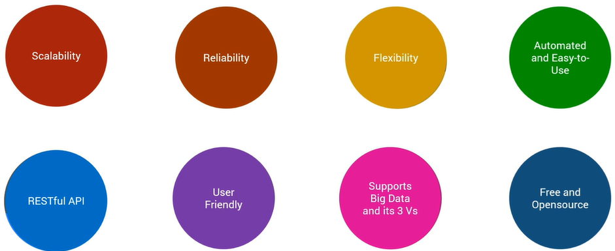

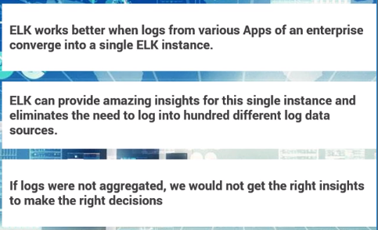



**Log Stash:**

**Overview:** It is an open source data collection engine with real time pipelining capabilities and can dynamically unify all these data form different sources and normalize the data to destinations of choice.

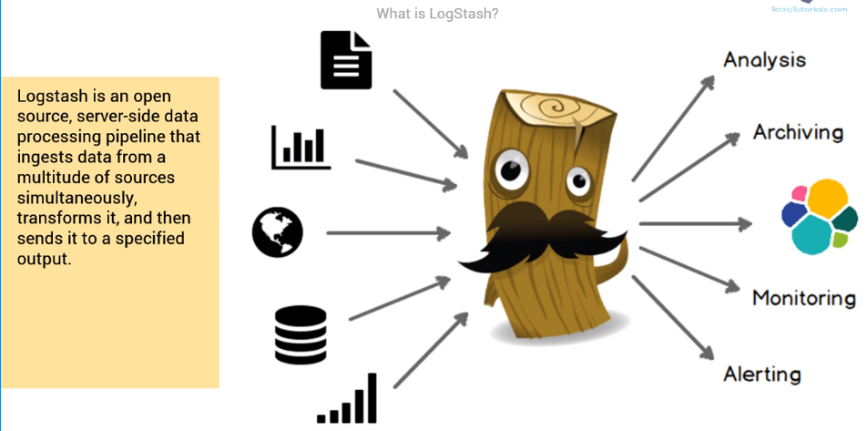

Any type of data is enriched by log stash and with a broad array of input filters and output plugins further simplifying the ingestion process.

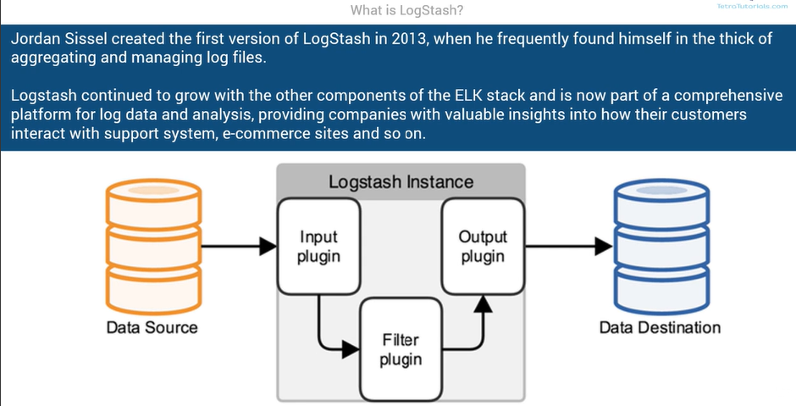

Importance:

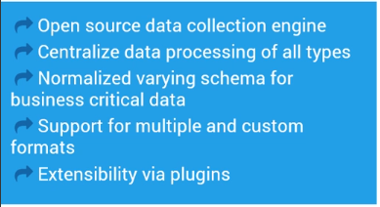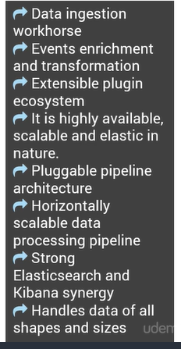

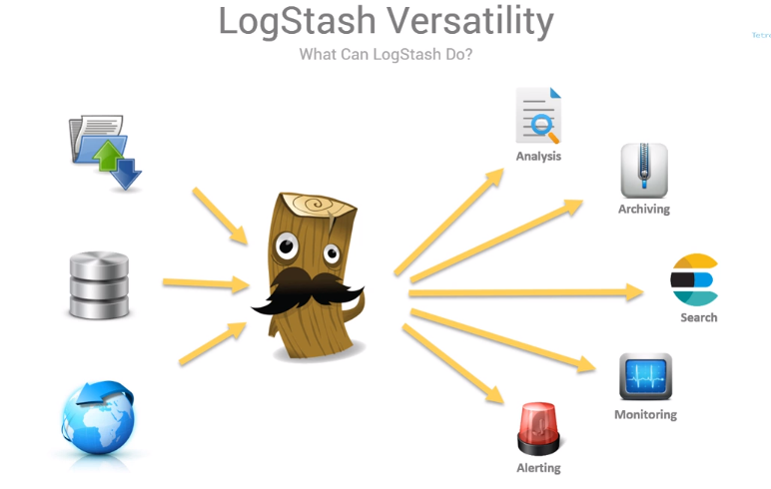

Components of Log stash:

* Log stash event processing pipeline has three stages or three plugins.
  + Inputs
  + Filters
  + Outputs

Inputs:

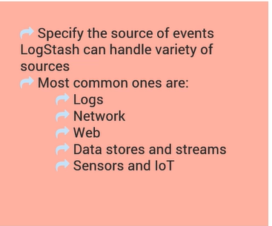

Filters:



**Grok**: parses unstructured log data in to something structured and quarriable.

**Mutate**: performs general transformation on event fields like replace, remove, rename and modify

**Drop**: drops the event completely. Usually all debug events are dropped and suppressed by this filter.

Outputs:

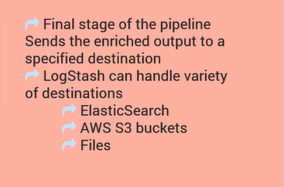

You can combine filters with conditions to meet certain criteria . After all these processing, enrichment and filtering this data is transferred to different systems like Elastic search, AWS S3 bucket or other files on disk.

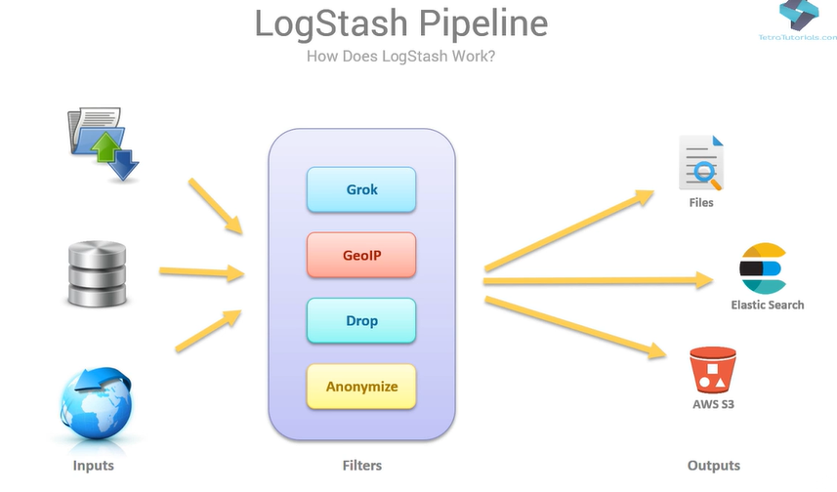

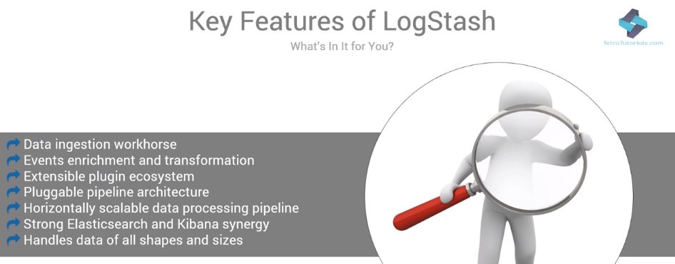

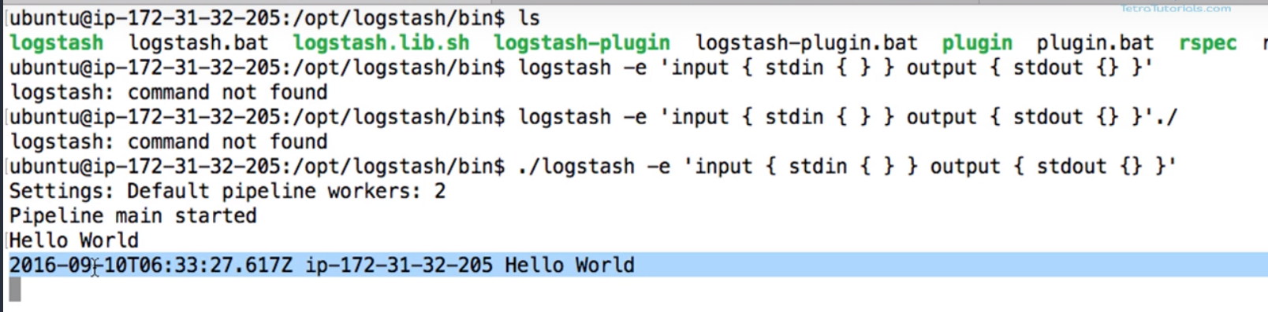

By running the log stash by using in command filter as console input and console output, pipeline will be started. Now by giving an input on the console, it will run through the pipeline and generated these three parts of the message( time stamp, Ip address and formatted msg).

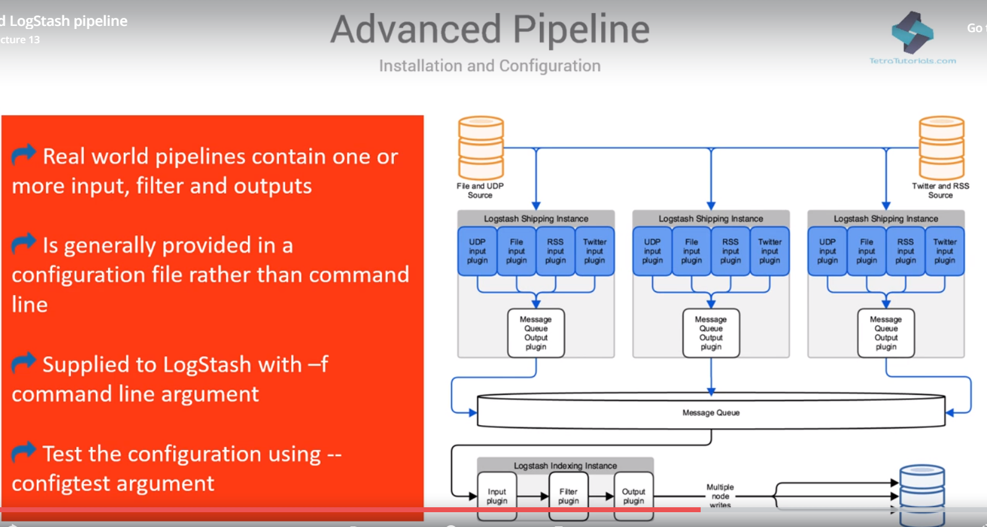

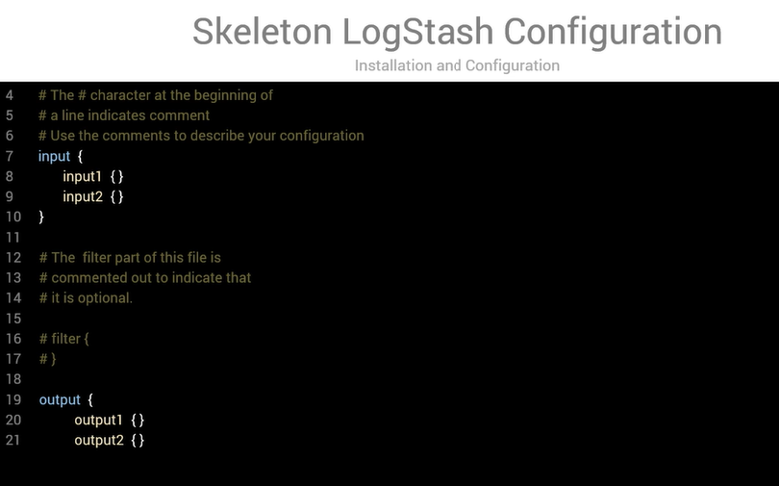

Log stash has rich library of plugins for all stages in the process.

Plugins for Input:

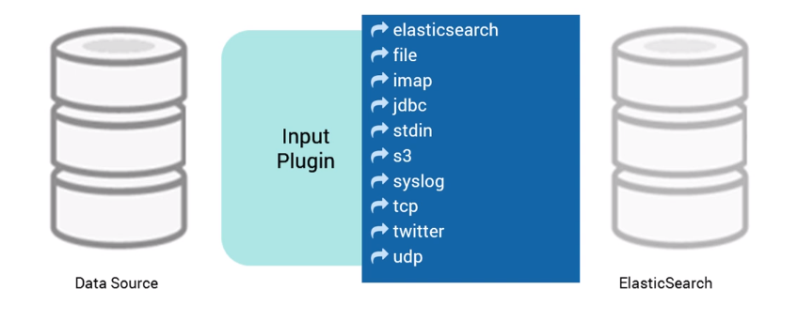

Filter Plugins:

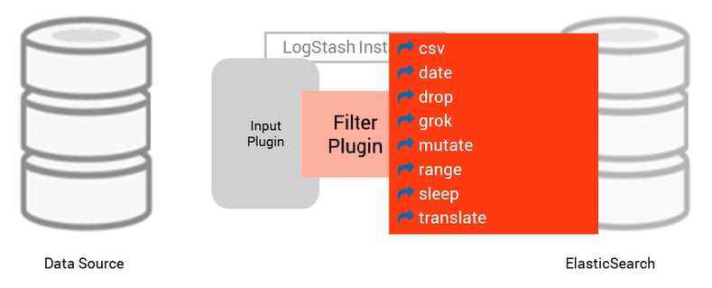

Output Plugins:

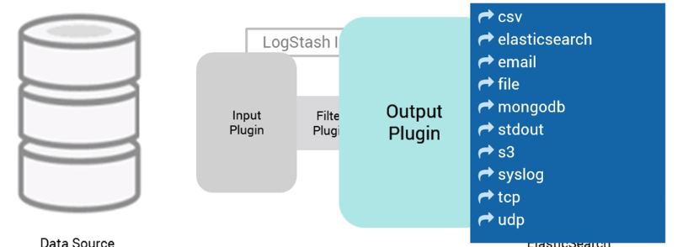

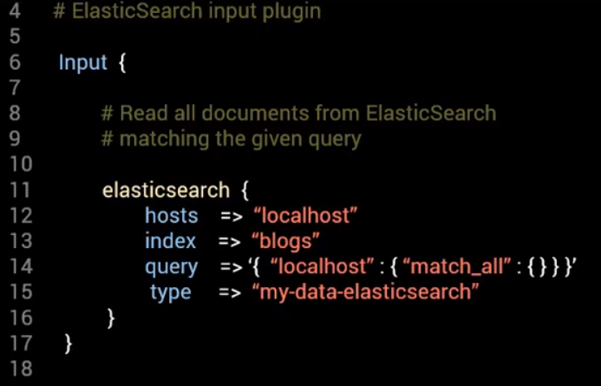

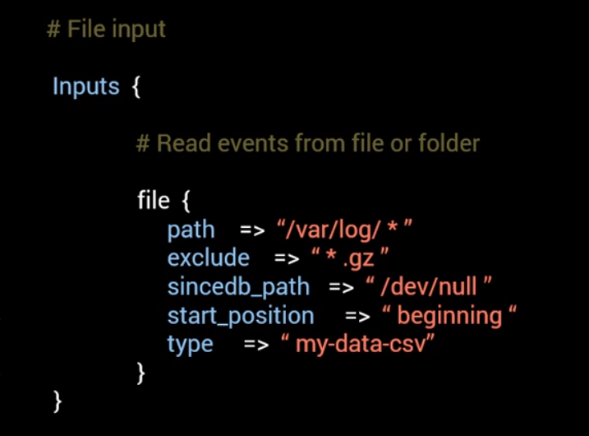

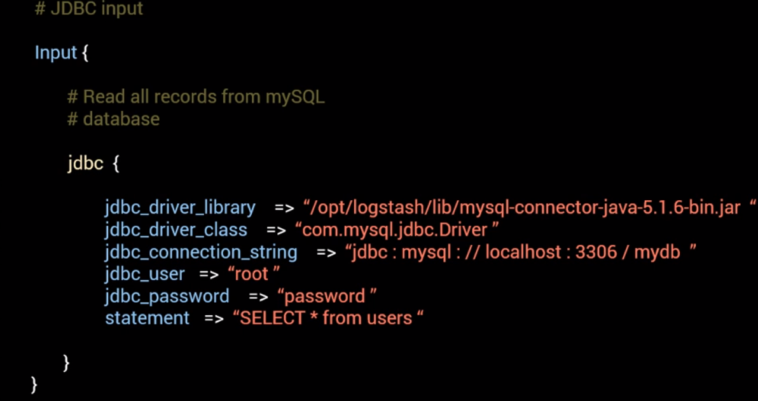

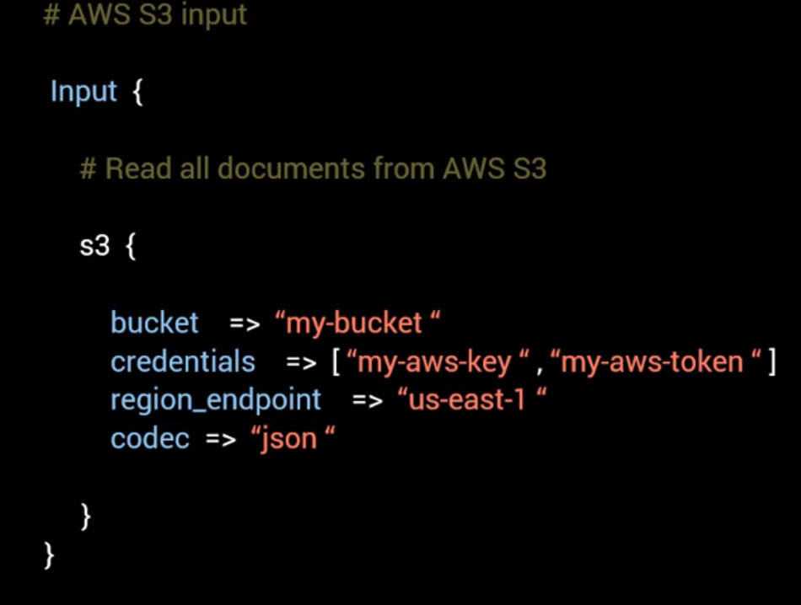

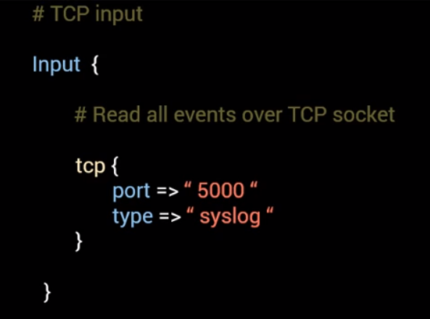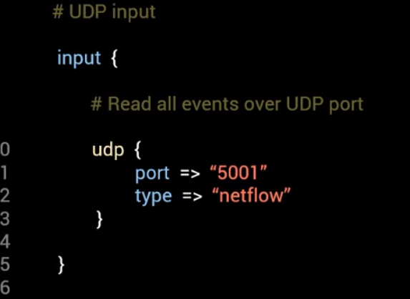

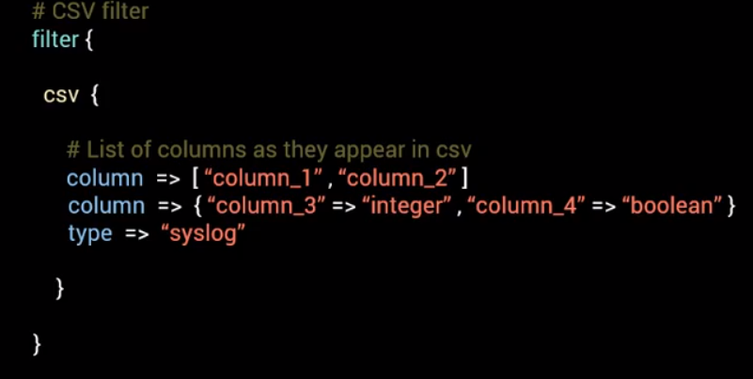

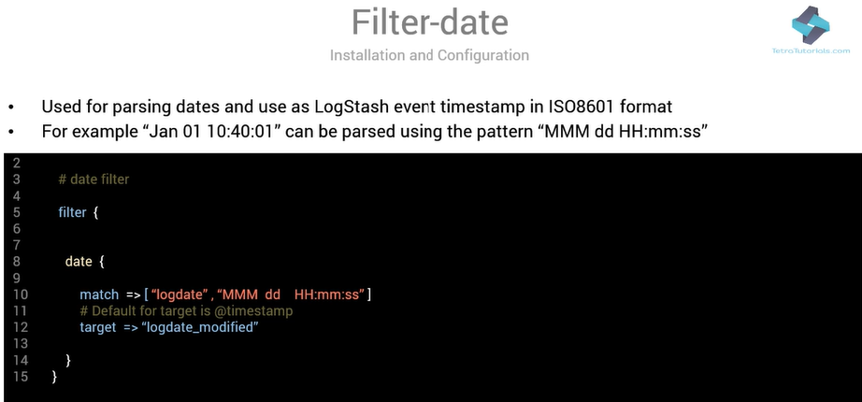

 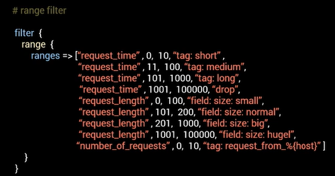

Grok:

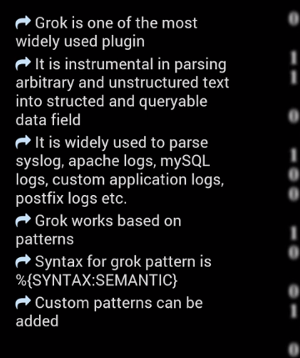f

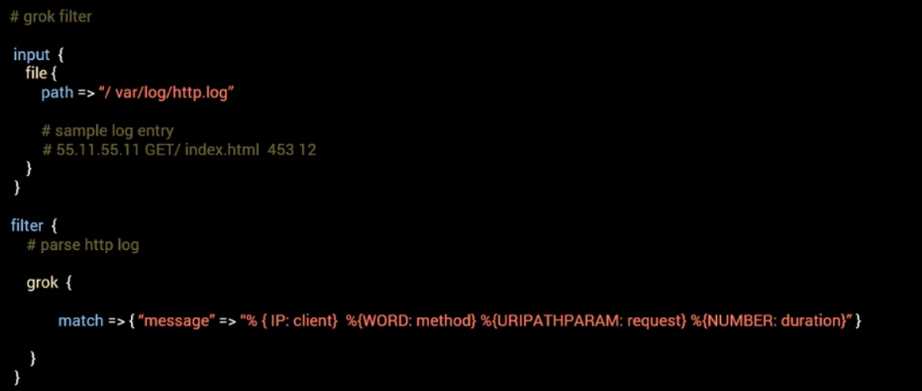

Grok supports custom patterns can plug them in conf file

* Inline patterns using Oniguruma syntax.
* File based custom patterns

Custom pattern:

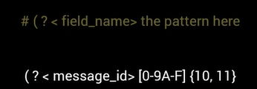

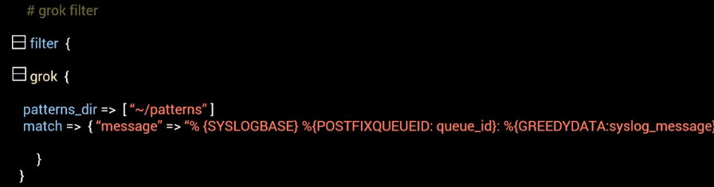

Mutate Filter:

* To perform mutations on the data.

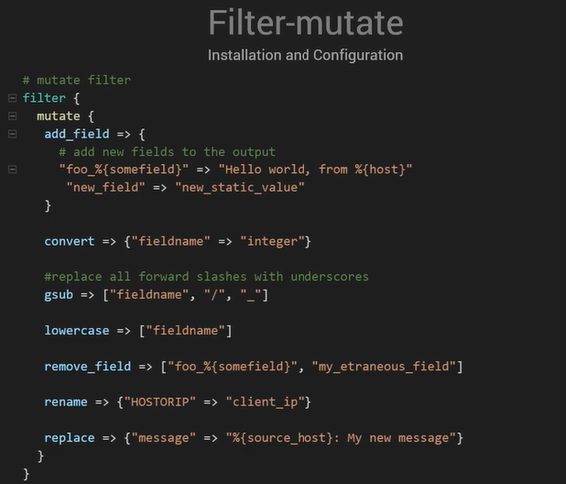

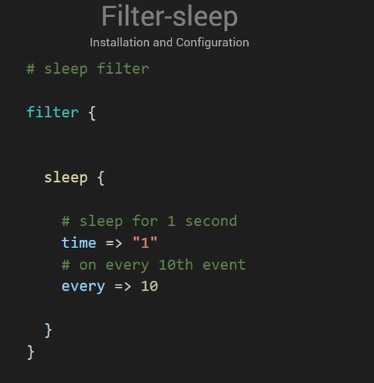 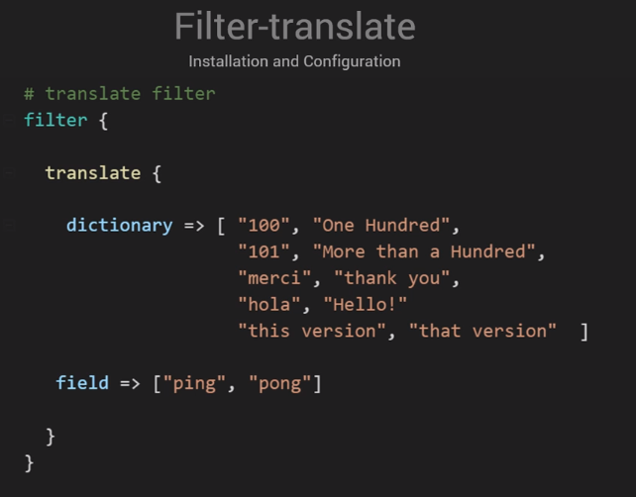

Output Plugins:

CSV: to write it in a comma delimited format

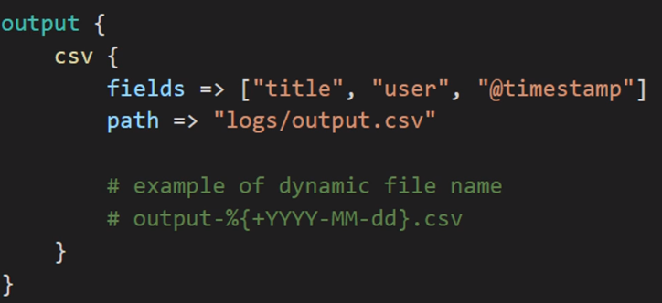

File: it writes all fields in JSON format to a output file.

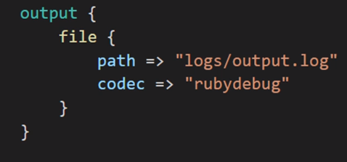 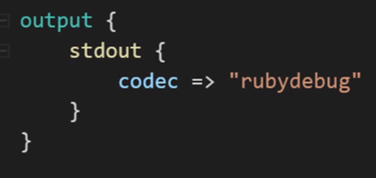

Elastic search:

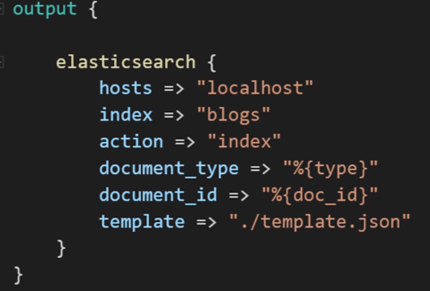

Email: alerts to Operational staff

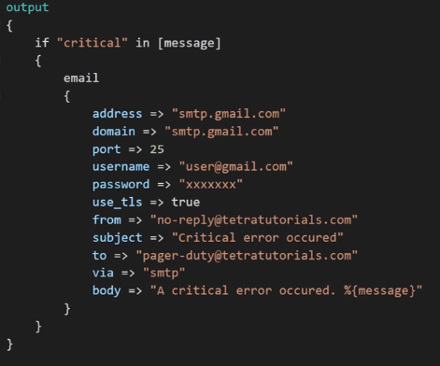

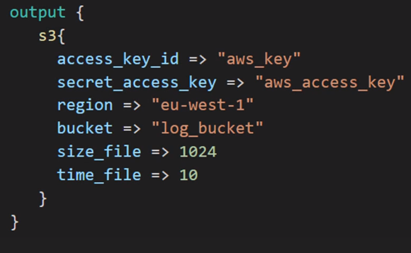

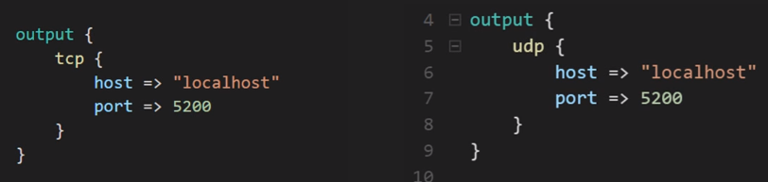

To test the configuration file:

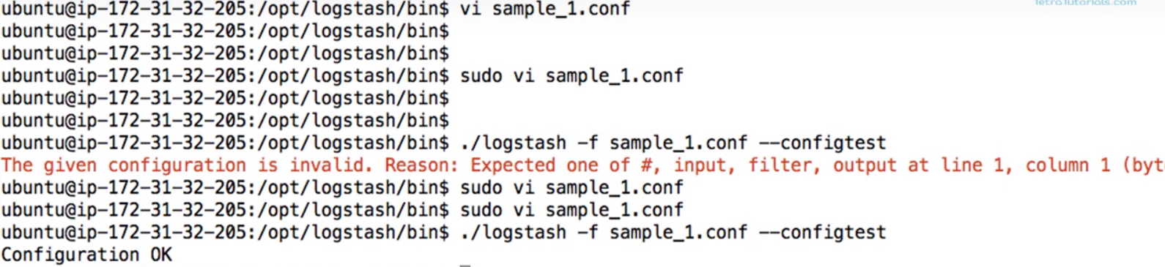

To run the pipeline: also inputted the string

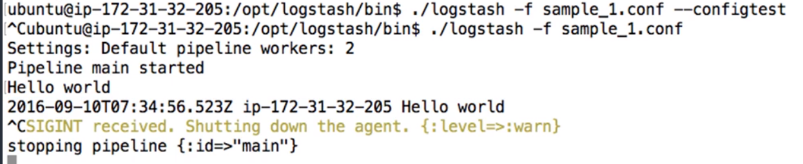

To format the output to human readable format use **rubydebug:**

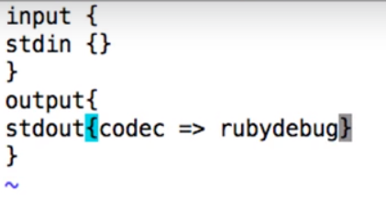

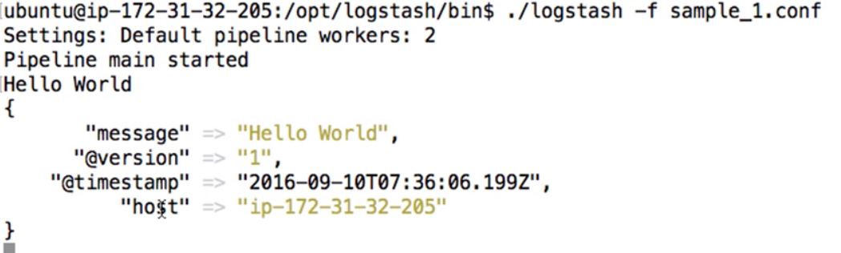

Example 2 conf file:

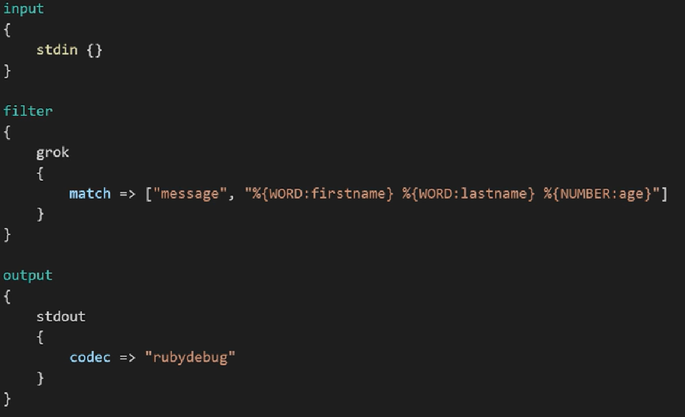

Output:

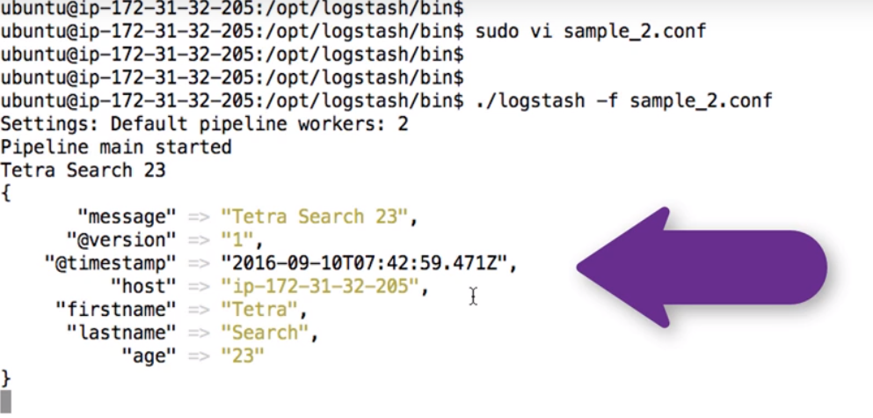

Having multiple outputs:

CSV output:

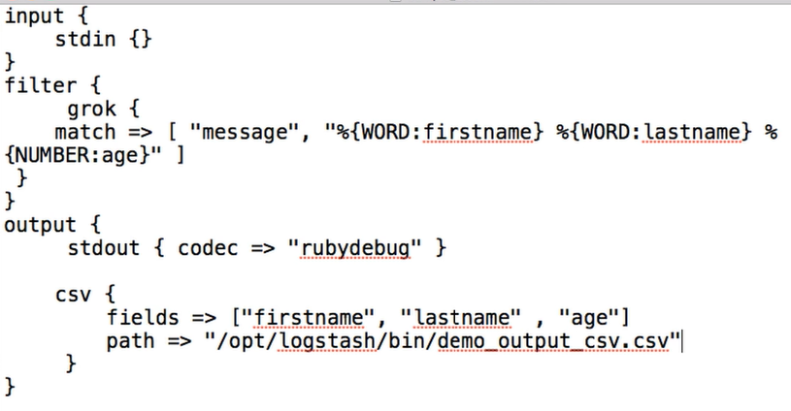

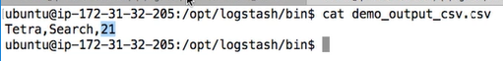

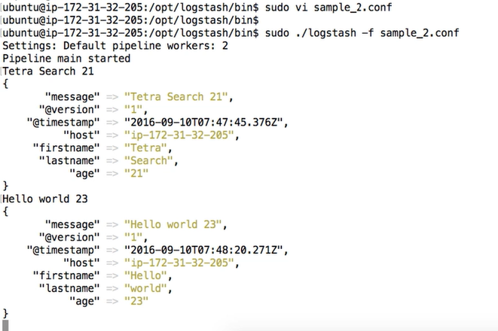

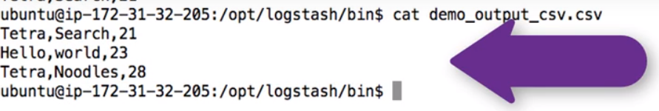

File output: everything will be written to file

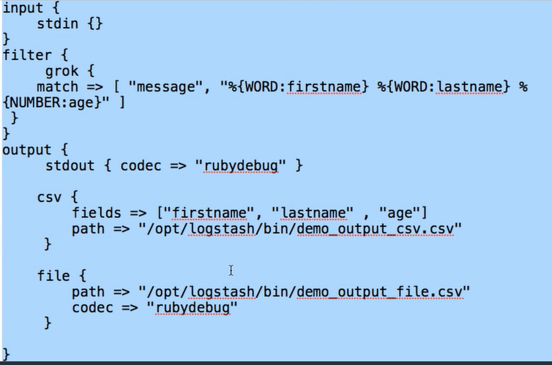

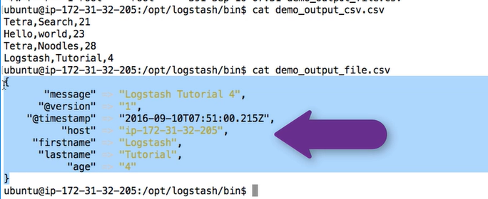

Elastic search:

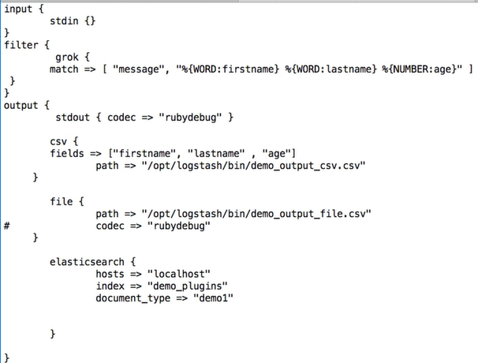

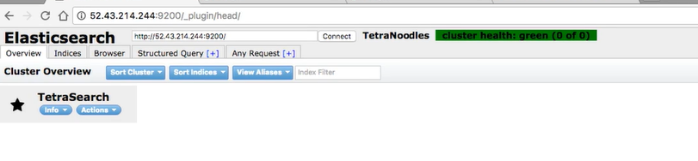

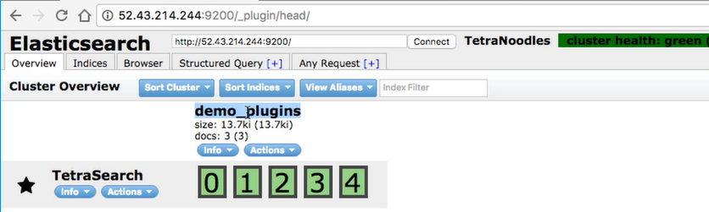

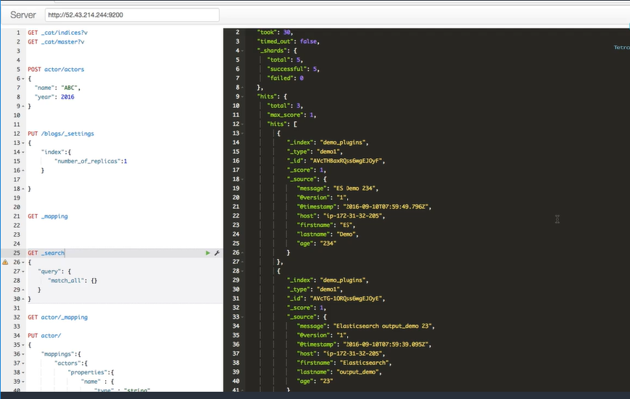

Pipeline to parse system log entries:

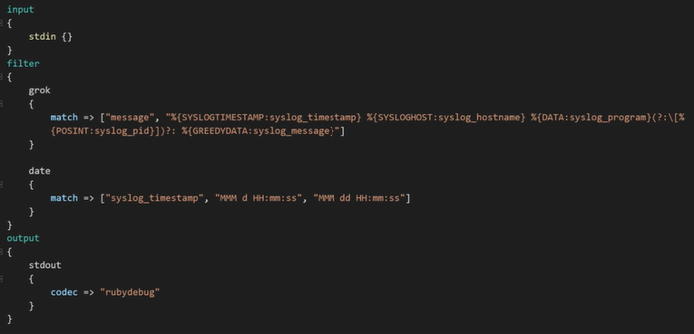

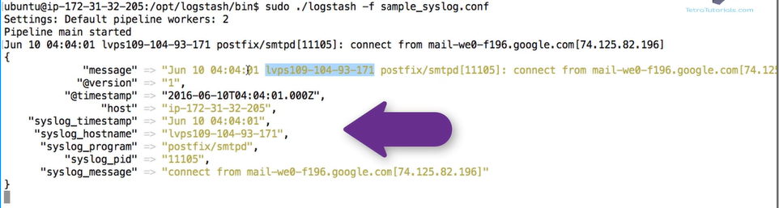

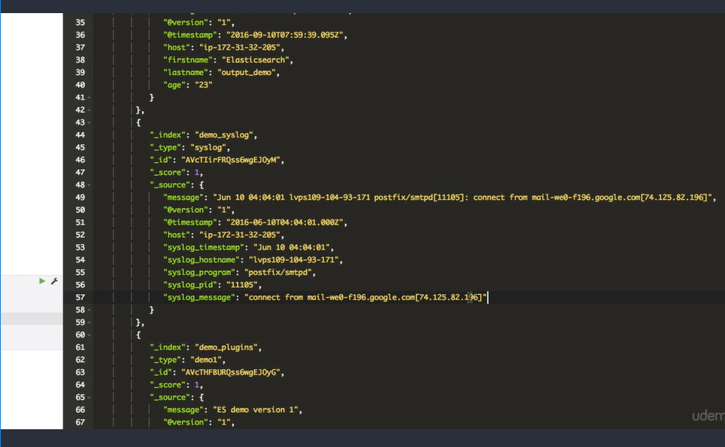

Pipeline for apache logs:

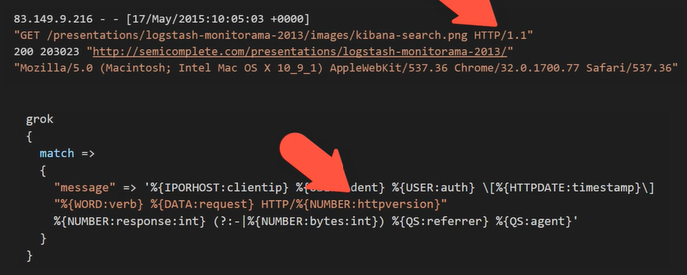

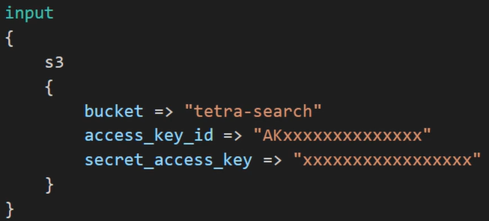

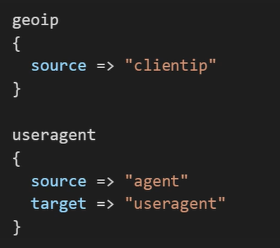

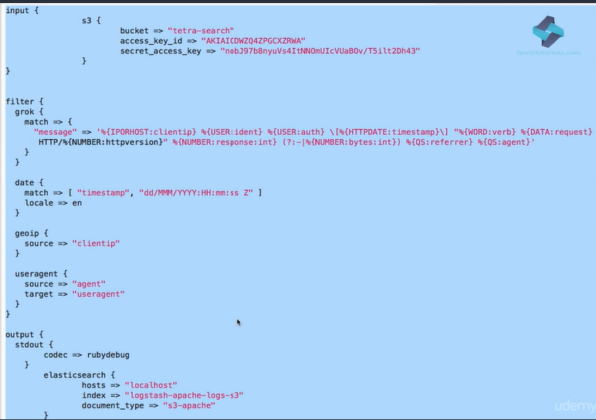

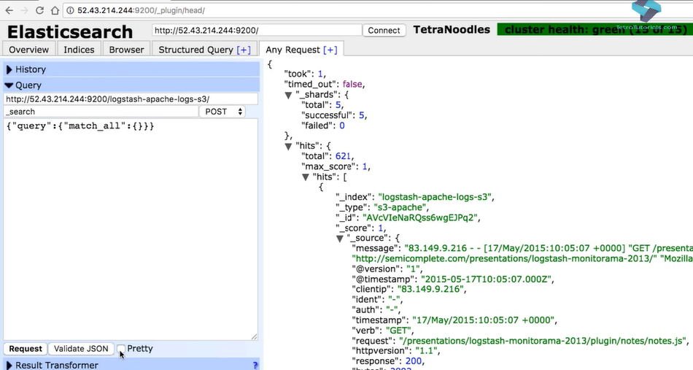

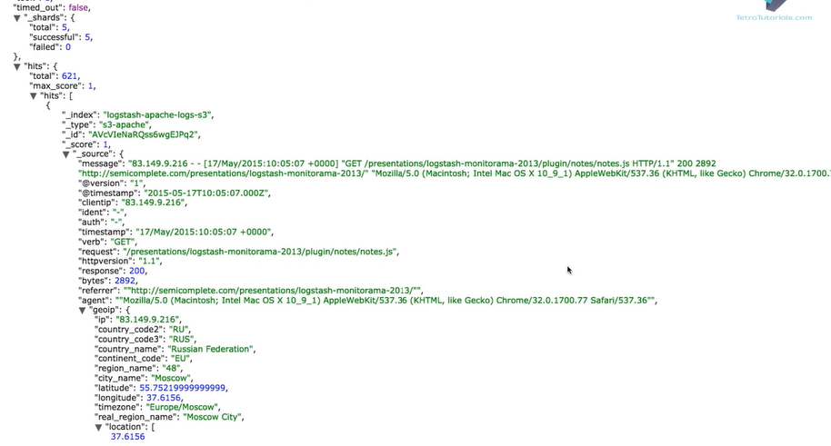

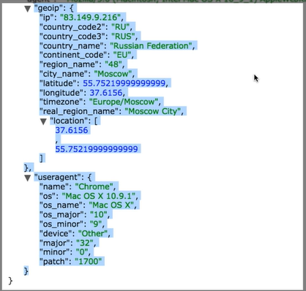

Pipeline to listen on TCP and UDP ports:

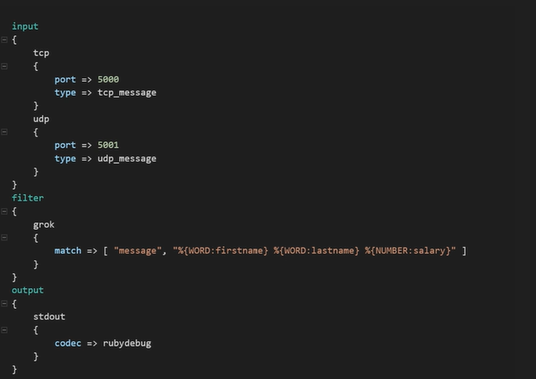

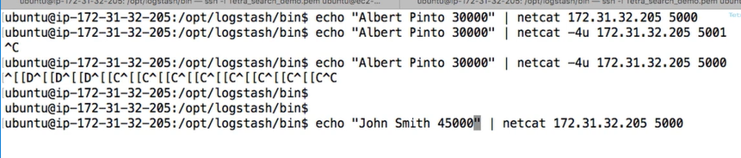

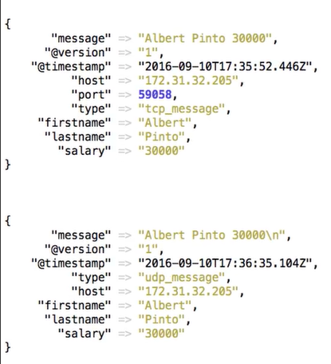

Pipeline for databases:

